BLOOM’S TAXONOMY

Outcome-Based Education (OBE)

As a student did you ever sit in a class and wonder, “Why is she talking about this?”

When we use student learning outcomes for planning lessons, designing assignments, lecturing, facilitating classroom discussions and other activities, this will not happen. Everything we do in the classroom should ultimately lead the student toward the outcomes of the course. Outcome-based education is an educational model in which curriculum and pedagogy and assessment are all focused on student learning. Simply put, OBE emphasizes student learning and success.

Therefore, if you think with that end in mind (the outcome), what will you do today to lead your students? On the following pages are some teaching guides and ideas, based upon Bloom’s Taxonomy.

What is Bloom’s Taxonomy?

In 1956, Benjamin Bloom, American educational psychologist, led a group of educational psychologists to develop a taxonomy, or classification system, for learning. He proposed that learning fits into one of three psychological domains:
- the Cognitive domain – processing information, knowledge and mental skills
- the Affective domain – Attitudes and feelings
- the Psychomotor domain – manipulative, manual or physical skills
Within each of these domains, he identified different levels of learning.

Cognitive Domain
Learning Outcomes Related to Knowledge

Knowledge | Comprehension | Application | Analysis | Synthesis | Evaluation
Cite | Convert | Apply | Analyze | Assemble | Access
Label | Define | Chart | Compare | Create | Appraise
List | Describe | Compute | Contrast | Construct | Conclude
Enumerate | Discuss | Demonstrate | Correlate | Design | Critique
Identify | Estimate | Determine | Diagram | Develop | Decide
Imitate | Explain | Dramatize | Dissect | Formulate | Defend
Match | Generalize | Establish | Differentiate | Generate | Diagnose
Name | Identify | Make | Distinguish | Hypothesize | Evaluate
Recall | Locate | Prepare | Investigate | Invent | Justify
Reproduce | Paraphrase | Project | Limit | Modify | Rank
State | Restate | Solve | Outline | Reframe | Recommend
Write | Summarize | Use | Separate | Synthesize | Support

Psychomotor Domain
Learning Outcomes Related to Skills

Observe | Model | Recognize Standards | Correct | Apply | Coach
Hear | Attempt | Check | Adapt | Build | Demonstrate
Identify | Copy | Detect | Adjust | Compose | Exhibit
Observe | Follow | Discriminate | Alter | Construct | Illustrate
See | Imitate | Differentiate | Change | Create | Instruct
Smell | Mimic | Distinguish | Correct | Design | Teach
Taste | Model | Notice | Customize | Originate | Train
Touch | Reenact | Perceive | Develop | Produce
Watch | Repeat | Recognize | Improve
 | Reproduce | Select | Manipulate
 | Show |  | Modify
 |  |  | Revise

Affective Domain
Learning Outcomes Related to Attitudes, Behaviors & Values

Receiving | Responding | Valuing | Organizing | Characterizing
Accept | Behave | Accept | Adapt | Authenticate
Attend | Comply | Adapt | Adjust | Characterize
Describe | Cooperate | Balance | Alter | Defend
Explain | Discuss | Choose | Change | Display
Locate | Examine | Differentiate | Customize | Embody
Observe | Follow | Defend | Develop | Habituate
Realize | Model | Influence | Improve | Internalize
Receive | Present | Prefer | Manipulate | Produce
Recognize | Respond | Recognize | Modify | Represent
 | Show | Seek | Practice | Validate
 | Studies | Value | Revise | Verify
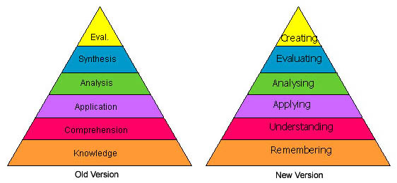
Source: http://www.odu.edu/educ/roverbau/Bloom/blooms_taxonomy.htm

During the 1990's a group of cognitive psychologists, and other educational experts, lead by Lorin Anderson (a former student of Bloom's), revised the taxonomy to reflect changes in terminology, structure, and emphasis.

Before we can understand a concept we have to remember it
Before we can apply the concept we must understand it
Before we analyze it we must be able to apply it
Before we can evaluate its impact we must have analyzed it
Before we can create we must have remembered, understood, applied, analyzed, and evaluated.

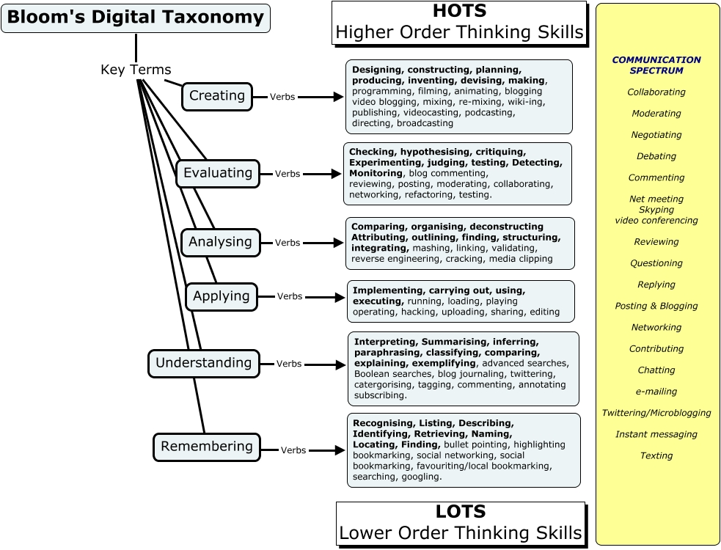

Church, A. (2009). Bloom's Digital Taxonomy Concept map. http://edorigami.wikispaces.com

Bloom’s Cognitive Domain with Instructional Ideas

Category | Verbs | Instructional Strategies / Products
Remember  Recognizing, Recalling | Arrange, Count, Define, Describe, Draw, Duplicate, Identify, Label, List, Match, Name, Order, Point, Quote, Read, Recall, Recite, Recognize, Record, Repeat, Reproduce, Select, State, Write | Analogies, Audio, Charts, Examples,  Illustrations, Lecture, Timelines, Video, Visuals Quiz, Definition, Fact, Worksheet, Test, Label, List, Workbook, Reproduction, Vocabulary
Comprehend  Interpreting, Exemplifying, Classifying, Inferring, Comparing, Explaining | Associate, Classify, Compare, Compute, Contrast, Convert, Describe, Differentiate, Discuss, Distinguish, Explain, Express, Extend, Generalize, Give Examples, Identify, Indicate, Locate, Listing, Matching, Paraphrase, Predict, Recognize, Report, Restate, Review, Rewrite, Select, Sort, Summarize, Tell, Translate | Discussion, Learner Presentations, Questions and Answers, Reports, Summaries, Recitation, Summary Collection, Explanation, Show and tell, Example, Quiz, List, Label, Outline
Apply  Executing, Implementing | Add, Apply, Calculate, Change, Choose, Classify, Complete, Compute, Demonstrate, Determine, Develop, Discover, Divide, Dramatize, Employ, Examine, Formulate, Graph, Illustrate, Interpret, Manipulate, Modify, Multiply, Operate, Organize, Perform, Practice, Predict, Prepare, Produce, Relate, Schedule, Shop, Show, Sketch, Solve, Subtract, Translate, Use | Demonstrations, Exercises, Microteach,  Practice, Projects, Role Play, Simulations,  Sketches Photograph, Illustration, Sculpture, Presentation, Interview, Performance, Diary, Journal
Analyze  Differentiating, Organizing, Attributing | Analyze, Appraise, Arrange, Breakdown, Calculate, Combine, Compare, Contrast, Criticize, Design, Detect, Determine, Develop, Diagram, Differentiate, Discriminate, Distinguish, Estimate, Examine, Experiment, Extrapolate, Formulate, Identify, Illustrate, Infer, Inspect, Inventory, Outline, Point Out, Question, Relate, Select, Separate, Subdivide, Test, Utilize | Case Studies, Critical Incidents, Discussion, Problems Graph, Spreadsheet, Checklist, Chart, Outline, Survey, Database, Mobile, Abstract, Report
Evaluate  Checking, Critiquing | Appraise, Argue, Assess, Attack, Choose, Compare, Conclude, Contrast, Criticize, Critique, Defend, Determine, Estimate, Evaluate, Grade, Interpret, Judge, Justify, Measure, Predict, Rank, Rate, Revise, Score, Select, Support, Test, Value, Weigh | Appraisals, Case Studies, Critiques, Exercises, Projects, Simulations Debate, Panel, Report, Evaluation, Investigation, Verdict, Conclusion, Persuasive speech
Create  Generating, Planning, Producing | Arrange, Assemble, Categorize, Collect, Combine, Compile, Compose, Construct, Create, Debate, Derive, Design, Devise, Explain, Formulate, Generate, Group, Integrate, Manage, Modify, Order, Organize, Plan, Prepare, Prescribe, Produce, Propose, Rearrange, Reconstruct, Relate, Reorganize, Revise, Rewrite, Specify, Summarize, Synthesize, Tell, Transform | Case Studies, Constructs, Creative Exercises, Develop Plans, Problems, Projects, Simulations Film, Story, Plan, New game, Newspaper, Media product, Advertisement, Painting, Song

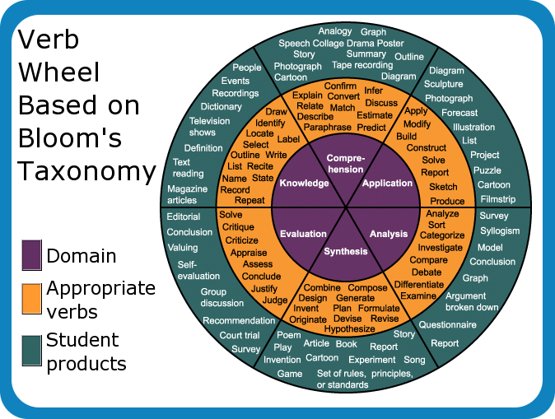

Source: http://www.alline.org/euro/images/bloomwheel.png

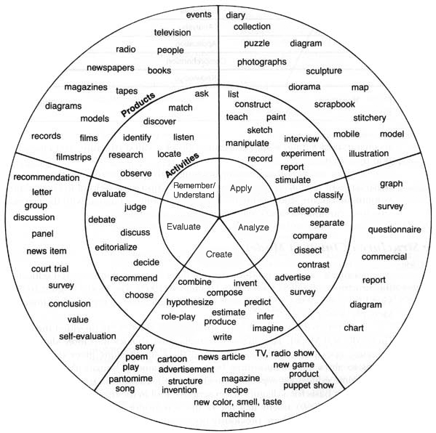

Source: http://www.cobbk12.org/sites/alt/training/Blooms/circle.GIF

Adapted from San Joaquin Valley College Student Earning Outcomes Toolkit

